We will find if there are trends with student graduation rates in the US. We will look at SAT scores and financial aid to see how they affect how long it takes for a student to graduate. We will look at the US as a whole and then narrow down to a specific state, California

How many students graduated each year from 2002 – 2013?

Just about half a million graduated in 2002. The numbers increased each year all the way to 2013, ending at around 0.7 million. The rate for 4 year graduates started at a low 30% and ended in the high 30% area. The 6-year year rate starts at 55% and ends at almost 60%. The overall graduation rate went up from about 88% in 2002 and ended at just below 100% in 2013.

You can see an overall increase in 4-year graduation rate. As we look at the data and take a closer look by state and see what variables affect this increase.

We are only looking at 4 year colleges. Without separating by gender or ethnicity.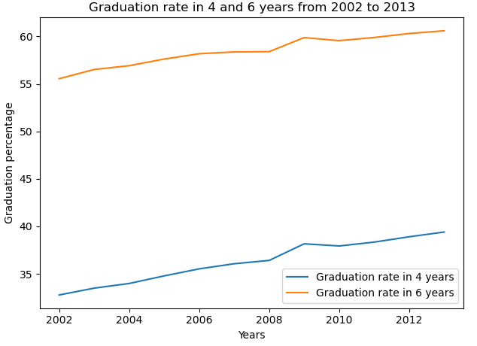

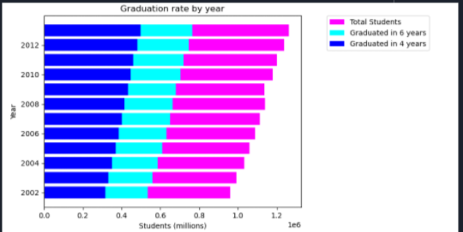

What type of school has the average highest graduation rate from 2002 - 2013? Overall and for the selected state.

Private non-profit schools had the highest rates for both 4 and 6 years. Public schools had the lowest rates. Private non-profit schools in general do a better job at preparing the students for graduation. This trend carried over to a single state, California. There are no private for profit schools but the private non-profit schools out perform the public schools.

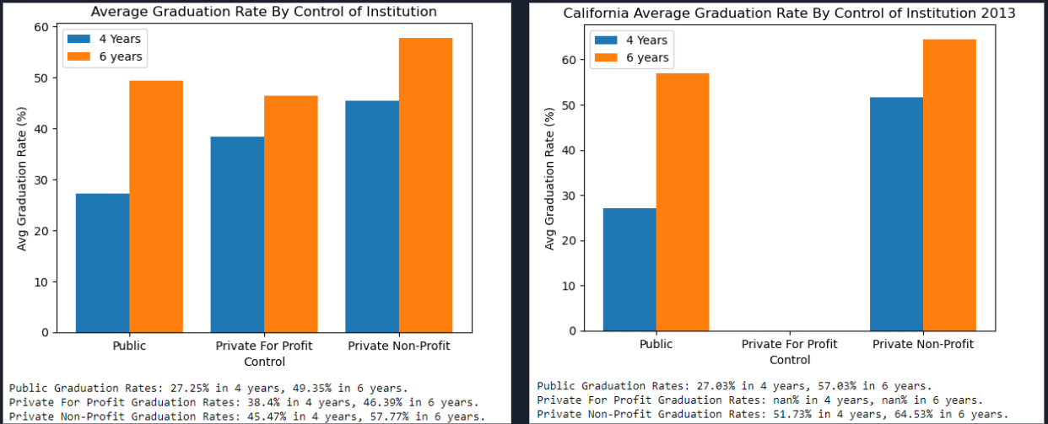

What is the effect on graduation rates based on financial aid amount in the selected state?

Financial aid has a clear effect on graduation rates over 4 and 6 years. The more a student received, the more likely they were to graduate.

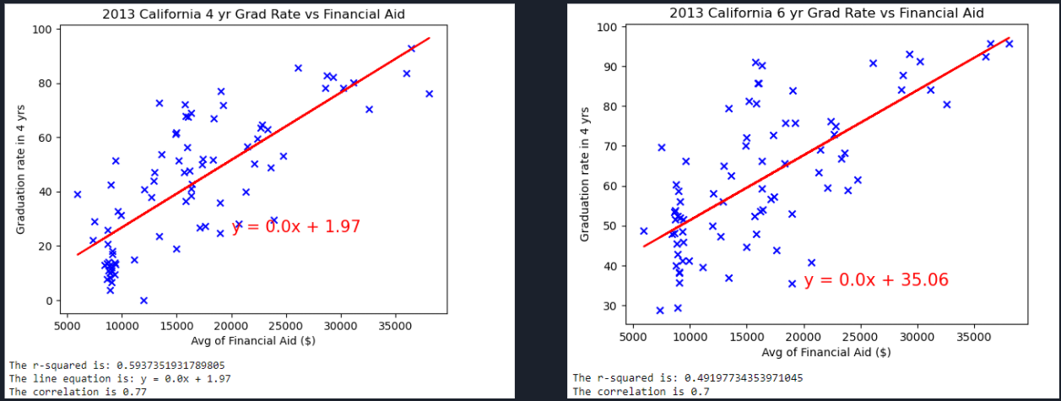

What is the effect on graduation rates based SAT scores in the selected state?

Schools that had higher median SAT scores saw more of their students graduate. The p-test shows a very high correlation.

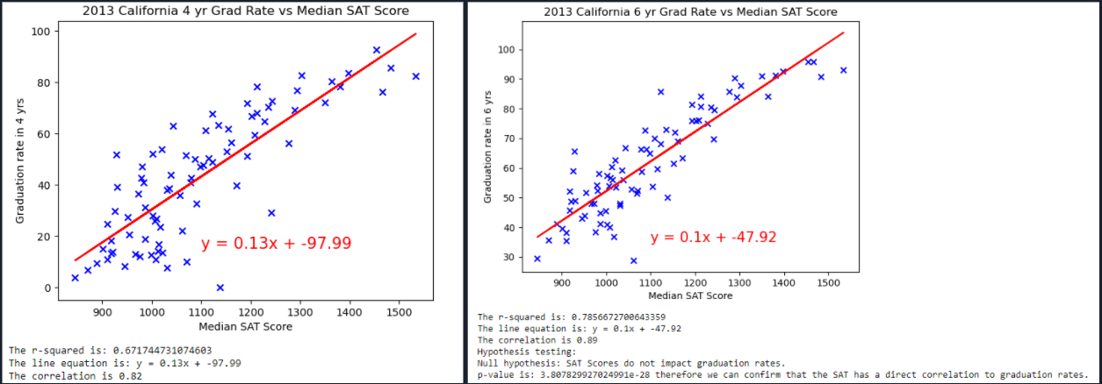

Does California have more 4 or 6 year graduates?

A majority of graduates in California took 6 years, longer than the traditional 4 years. We don’t have data on the possible external factors that could be attributing to the longer graduation time.

